

REPORT
ON
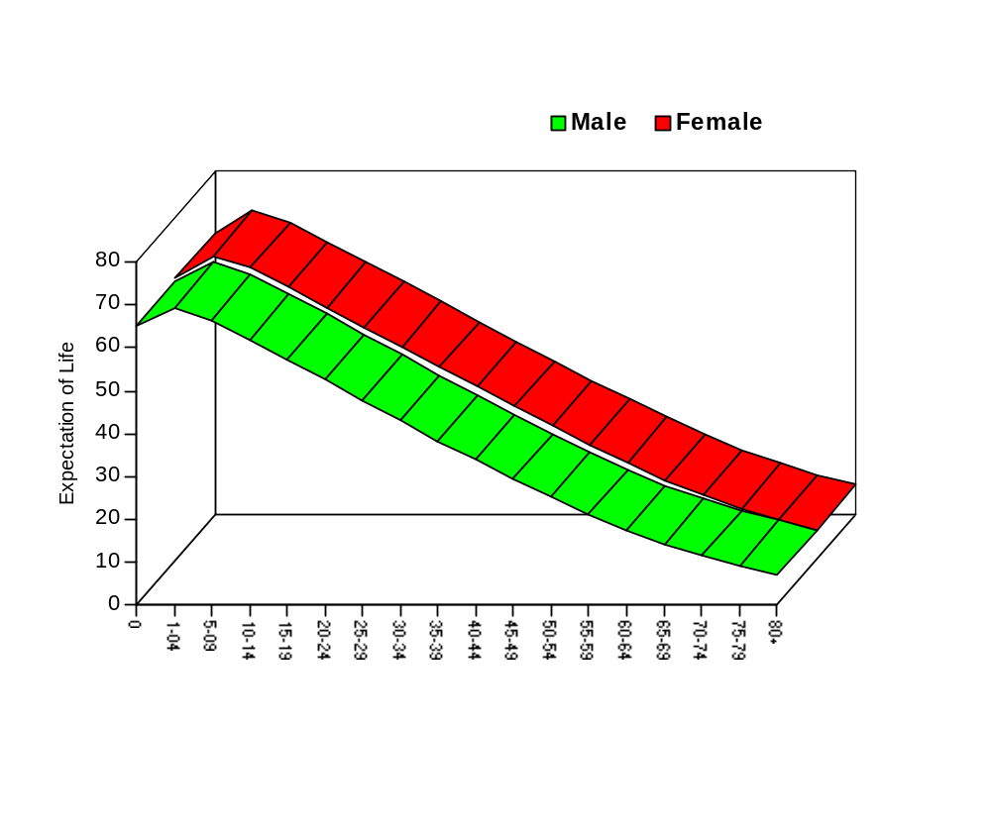SAMPLE VITAL REGISTRATION SYSTEM, 2004

DECEMBER, 2006

evsjv‡`k cwimsL¨vb ey¨‡iv
BANGLADESH BUREAU OF STATISTICS
evsjv‡`k cwimsL¨vb ey¨‡iv
BANGLADESH BUREAU OF STATISTICS

Expectation of Life at Birth by Sex
Age Group

Life expectancy at birth is an age standardized summary measure of mortality. It reflects the outcome of overall improvement of health condition of a country. In 2004, the expectation of life for males stands at 64.4 years and for females 65.7 years. This rate is comparatively higher than previous years.

DECEMBER 2006

evsjv‡`k cwimsL¨vb ey¨‡iv
BANGLADESH BUREAU OF STATISTICS

Foreword

Population census produces landmark information about the population, its composition and spatial distribution for the first year of each decade. During the inter censal period, it is necessary to determine the annual changes in population parameters, its composition and size for the use of the planners, policy makers, researchers and the development partners. To this end, Sample Vital Registration System (SVRS) was introduced by Bangladesh Bureau of Statistics (BBS) in 1980. Since then, the Sample Vital Registration System is a regular core activity of BBS.

The objective of the health and population programme of the government is to reduce the population growth rate, mortality rate, particularly the infant, child and maternal mortality rate, improve reproductive health, adolescent health and control communicable diseases. The health and population related Millennium Development Goals (MDG) also have the target to reduce infant mortality by two thirds between 1990 to 2015, reduce maternal mortality by three quarter between 1990-2015, to reduce 50% of the spread of HIV AIDS and so forth. In order to observe the changes in the targets and indicators of MDG, there is no alternative but to collect, compile and disseminate the health and population related data on a regular basis. I believe that the report of SVRS-2004 will help towards that end.

I would like to thank the Director General, BBS, Director, Demography and Health Wing, Project Director, SVRS Project and their colleagues for their relentless and wholehearted efforts to prepare this report.

I hope that, this report would be useful to planners, policy makers, development partners and researchers to prescribe appropriate policy measures for the reduction of population growth and improvement of the health status of the population. Any constructive suggestion and comment from the users for improvement of the report will be most welcome.

________________________
Jafar Ahmed Choudhury
Secretary
Planning Division
Ministry of Planning

Preface

Bangladesh Bureau of Statistics has been conducting the Sample Vital Registration System (SVRS) since 1980. The objective of the Sample Vital Registration System of BBS is to collect, compile and publish demographic data in between inter censal period. Over the years, the vital registration system has been improved and the sample coverage has been increased to provide demographic indicators at the sub national levels.

The strength of this sample vital registration is the collection of data under dual record system to estimate demographic indicators using Chandrasekaran and Deming Technique. Under this system vital events are collected as and when it occurs by a locally recruited registrar termed as Local Registrar (LR) (System-1). On the other hand, under a second system another group of officials from Upazila Offices of BBS also collect the data from the same area on a quarterly basis (System-2). After getting the questionnaire from the two systems, data are matched in headquarter by pre-designed matching criteria and the demographic rates and ratios are calculated by Chandrasekaran Deming Technique.

In order to get denominators for the demographic parameter a detailed household survey is conducted every year covering basic household characteristics.

The report on the sample vital registration system 2004 is based in the vital events collected during 2004 and validated by a group of senior officers of BBS through extensive filed visit.

I would like to thank the local Registrars, Supervisors, Upzila Statistical Officers, Regional Statistical Officers for the filed work and supervision of the data collection. The report is prepared by a Team lead by Mr. Anwar Hossain, Project Director, who was assisted by Mr. Hafizur Rahman, Deputy Director and Mr. Aminul Islam, Statistical Officer. The task of data processing was done by Mr. Abul Kashem, Programmer. All of them deserves special appreciation. Thanks is also due to Director, Demography and Health wing of BBS, who rendered technical support for preparing the report.

Suggestions and Comments for further improvement of the report is most welcome.

(A. Y. M. Ekramul Haque)
March 2007 Director General
Bangladesh Bureau of Statistics

Technical Note

Sample Vital Registration System:

Sample Vital Registration System was introduced by Bangladesh Bureau of Statistics in 1980 to determine the annual population change during inter-censal period. Initially it’s coverage was 103 primary sampling unit (PSU) each comprising of about 250 continuous households. Out of 103 PSUs data need of planner, 62 PSUs were from rural and 41 PSUs were from urban area. To meet the planning need and users demand number of sample PSUs was raised to 210 PSUs in 1983. This could provide estimate at the division level. At the same time its scope was raised with marriage and migration. Considering the importance of the project it was transferred to revenue set up of BBS in 1991. At that time zila became the focal point of development. To meet the users demand for zila estimate number of sample PSUs was again raised to 500 in 1995. The scope of the survey was also enhanced with the addition of a new module on contraceptive use. A household card was introduced for updating of household information. With the availability of the sampling frame from the latest Population Census 2001 the sample design was recast. An Integrated Multi-purpose Sample Design was introduced with effect from 01-7-2000 with 1000 PSUs.

Dual Recording System:

To obtain data from field with extensive verification Chandrasekaran and Deming Dual Recording System was introduced from the beginning. Under system-1 there was a local registrar for each PSU who used to collect data about each event as and when it occurs and record it in the specified schedule and then return the filled-in schedules to the headquarters according to the time table set for each schedule. Under system-2 supervisors from the Upazila Statistical Offices and the officers from the headquarters visit the PSUs on quarterly basis and collect retrospective data on all the events. The filled-in schedules obtained from both the systems were coded and matched at the headquarters and re-investigation are done where needed. After the cross verification of data estimates are prepared and published using the Chandrasekaran Deming Technique.

Schedule:
To systematize collection of data from the field different types of schedules were introduced which are summarized below:
Schedule 1: House listing
Schedule 2: Household card
Schedule 3: Birth
Schedule 4: Death
Schedule 5 : Marriage
Schedule 6: Divorced/Separated
Schedule 7: Out-migration
Schedule 8: In-migration
Schedule 9: Contraceptive use
Schedule 10: Disability
Remuneration:
Initially, in 1980 rate of remuneration for each local registrar was Tk.100/- in the rural area and Tk.150/- in the urban area. Considering the increase in cost of living the rate of remuneration was raised to Tk.250/- in 1983 in both the urban and rural areas. This rate continued till the introduction of the new project “Strengthening of Sample Vital Registration System” in 2000. Prior to that remuneration was a bottleneck to registrars active participation in the SVRS activities.

Strengthening of Sample Vital Registration System Project was introduced in July 2000 to strengthen the SVRS in BBS from 500 PSUs to 1000 PSUs in the light of the latest population census and produce estimate at the zila level. On review it was observed that the sampling frame on which the then sample design was based has become obsolete and slightly ineffective because of no change in the remuneration rate and limitation of the then SVRS to produce estimate with urban-rural break-up. It was felt to develop an integrated multipurpose sample (IMPS) design on the basis of population census 2001 frame which could be used for health and other socio-demographic surveys also.

Organizational Set-up
Strengthening of Sample Vital Registration System Project was thus undertaken in 2000 to strengthen the regular vital registration activities carried out by the Demography and Health Wing of BBS. Two new schedules – one on divorce and separation and one on disability were introduced.

The specific objectives of the project were –
- to develop an IMPS on the basis of population census 2001 sampling frame with 1000 PSUs so that reliable estimates on vital events such as birth, death, marriage, migration, contraceptive use, disability, divorce and separation can be produced at the zila level with urban- rural break- up;
- to review and revise the schedules where necessarily;
- to provide extensive training to the local registrars and the upazila supervisors so that reliable data are collected and sent to headquarters in time;
- to enhance the remuneration of the registrars from Tk. 250/- per month to
Tk. 500/- per month each which is more reasonable; and
- to prepare the report on the basis of IMPS in time.

Estimation of indicators and preparation of data base:
Now remuneration is provided for the registrar of 500 PSUs jointly from the wings budget (@ Tk. 250/- each) and project’s budget (@ Tk. 750/- each). For effective supervision of each PSU each supervisor was given Tk.250/- per month as conveyance from the project. For the remaining 500 PSUs the entire remuneration are paid from the project’s budget @ Tk. 1000/- each. After switching over to the new system, data for January – December 2004 was continuously collected from 1000 new PSUs under the supervision of the wing and the project. Some indicators of SVRS-2004 were also checked with the provisional indicators of SVRS- 2005.

Report
Report has been prepared for the calendar year 2004 with July 1 as the mid-year. For each indicator a time series is added to the report. To obviate users confidence interval estimation of key indicators were done and added in the report.

Md. Anwar Hossain
Project Director
Strengthening of Sample Vital Registration System Project
Bangladesh Bureau of Statistics

Table of Contents

 | Page
Foreword | V
Preface | VII
Technical Note | IX-X
Table of Contents | XI
Key Indicators at a Glance | XIII-XIX
Chapter 1: Survey Design | 1-8
Chapter 2: Methodology | 9-12
Chapter 3: Household Characteristics | 13-22
Chapter 4: Population Characteristics | 23-36
Chapter 5: Fertility | 37-50
Chapter 6: Mortality | 51-80
Chapter 7: Expectation of Life | 81-84
Chapter 8: Nuptiality | 85-98
Chapter 9: Contraceptive Use | 99-105
Chapter 10: Internal Migration | 105-110
Chapter 11: Measures of Reliability and Confidence Limit | 111-116
Chapter 12: Appendices
Annexure 1: Tabulations | 119-120
Annexure 2: Technical Committee Members and List of Contributors | 192-193
Annexure 3: Concepts and Definitions | 194-197
Annexure 4: Schedules | 198-207
Annexure 5 : References and Abbreviations | 208-209

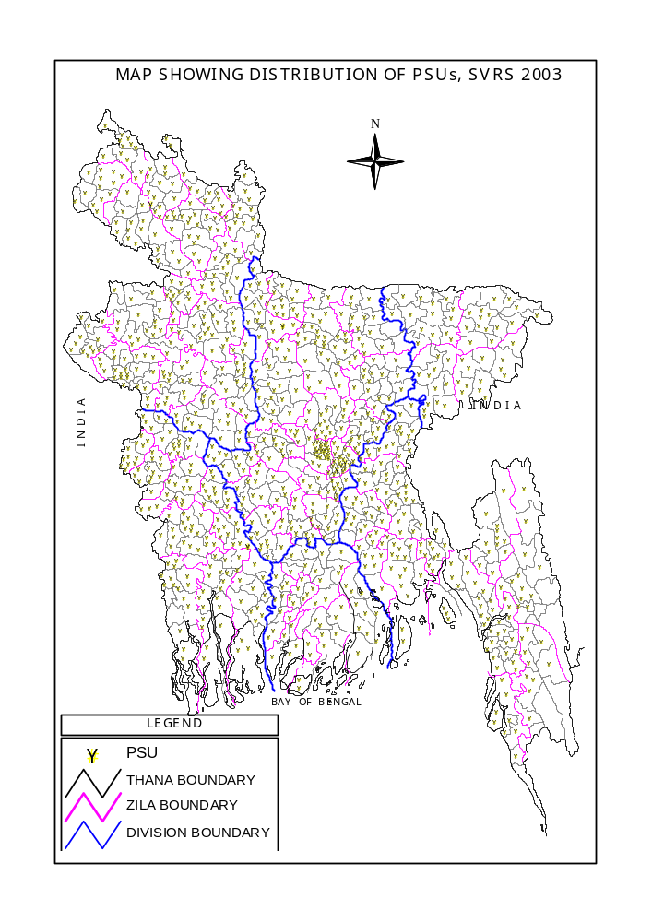
Key Indicators on Report of Sample Vital Registration System 2004

Indicator | 2004 | 2003 | 2002 | 2001 | 2000
A. Population and Age Structure
01.Population (1st July) (in million)
Both Sexes | 136.7 | 134.8 | 132.9 | 131.1*  130.0 | 129.3
Male | 70.1 | 69.1 | 68.2 | 67.1 | 66.3
Female | 66.6 | 65.7 | 64.7 | 62.9 | 63.0
02. Growth Rate (Annual) | 1.42 | 1.43 | 1.40 | 1.54 | 1.41
03. Urban Population ( in million) | 32.4 | 31.3 | 30.6 | 30.0 | 29.6
04. Sex Ratio | 105.2 | 105.2 | 105.4 | 106.6 | 105.4
05. Population by Broad Age-group (Percent)
Both Sexes
00-14 | 37.9 | 38.1 | 38.3 | 39.3 | 39.4
15-49 | 50.3 | 50.2 | 50.0 | 49.4 | 48.7
50-59 | 5.6 | 5.5 | 5.5 | 5.1 | 6.2
60+ | 6.2 | 6.2 | 6.2 | 6.2 | 5.7
Male
00-14 | 38.2 | 38.4 | 38.6 | 40.0 | 39.4
15-49 | 49.1 | 49.0 | 48.9 | 48.0 | 48.4
50-59 | 6.0 | 5.9 | 5.8 | 5.4 | 6.2
60+ | 6.7 | 6.7 | 6.7 | 6.6 | 6.0
Female
00-14 | 37.7 | 37.8 | 38.1 | 38.5 | 39.4
15-49 | 51.5 | 51.4 | 51.2 | 51.0 | 49.1
50-59 | 5.2 | 5.1 | 5.1 | 4.9 | 6.0
60+ | 5.7 | 5.7 | 5.6 | 5.7 | 5.5
06. Dependency Ratio (Percent)
- National | 79 | 79 | 80 | 76 | 75
- Rural | 83 | 84 | 84 | 82 | 79
- Urban | 64 | 64 | 65 | 59 | 65
07. Child Women Ratio (Per 1000)
- National | 476 | 482 | 491 | 526 | 460
- Rural | 500 | 510 | 520 | 563 | 487
- Urban | 386 | 387 | 388 | 409 | 395
08. Population Density (Sq. km) | 926 | 913 | 901 | 881 | 876
B. Household Characteristics
09 Household Size | 4.8 | 4.8 | 4.9 | 4.7 | 4.8
10 Headship (Percent)
- Male Headed HH | 89.6 | 89.5 | 89.6 | 87.1 | 89.3
- Female Headed HH | 10.4 | 10.5 | 10.4 | 12.9 | 10.7
Note: Figures in shades are the census ones
* Population, as of 1st July, 2001

Indicator | 2004 | 2003 | 2002 | 2001 | 2000
11. Access to Drinking Water (Percent)
- Drinking (Tap & Tube well) | 97.4 | 97.3 | 96.7 | 90.7 | 96.5
- Other use (Tap & Tube well) | 52.5 | 52.3 | 51.9 | NA | NA
12. Source of Light (Percent)
- Kerosene | 62.8 | 63.3 | 65.1 | 68.0 | 62.6
- Electricity | 37.2 | 36.4 | 34.4 | 31.5 | 36.4
- Others | 0.0 | 0.3 | 0.5 | 0.5 | 0.5
13. Toilet Facility (Percent)
- Sanitary | 45.5 | 42.5 | 39.9 | 36.9 | 43.4
- Other | 36.8 | 37.7 | 39.2 | 41.5 | 50.3
- None | 17.7 | 19.8 | 20.9 | 21.6 | 6.3
C. Nuptiality
14. Crude Marriage Rate (Per 1000 Population)
- National | 12.5 | 10.4 | 9.5 | 8.9 | 9.0
- Rural | 13.5 | 11.1 | 9.9 | 9.7 | 9.8
- Urban | 8.2 | 7.4 | 7.5 | 6.0 | 6.1
15. Marital Status of Population
(Age 10+) by Type and Sex (Percent)
15.1 Male
- Never Married | 42.6 | 42.3 | 41.3 | 43.6 | 43.5
- Currently Married | 56.8 | 57.0 | 58.0 | 55.8 | 55.4
- Widowed/ Divorced/ Separated | 0.6 | 0.7 | 0.7 | 0.6 | 1.1
15.2 Female
- Never Married | 28.5 | 28.3 | 27.1 | 28.7 | 31.6
- Currently Married | 63.1 | 63.2 | 64.2 | 63.3 | 60.1
- Widowed/ Divorced/  Separated | 8.4 | 8.5 | 8.7 | 8.0 | 8.3
16. Mean Age At Marriage
16.1 Male
National | 25.3 | 25.2 | 25.6 | 25.8 | 27.7
Rural | 25.1 | 25.0 | 25.3 | 25.1 | 27.1
Urban | 26.5 | 26.7 | 26.9 | 27.0 | 28.9
16.2 Female
National | 19.0 | 20.4 | 20.6 | 20.4 | 20.4
Rural | 18.9 | 20.2 | 20.4 | 20.1 | 20.1
Urban | 19.9 | 21.5 | 21.4 | 21.3 | 21.2
17. Singulate Mean Age at Marriage
17.1 Male
National | 25.4 | 25.5 | 25.3 | 25.3
Rural | 25.2 | 25.3 | 25.1 | 24.8
Urban | 26.3 | 26.2 | 25.9 | 26.8
17.2 Female
National | 19.4 | 19.4 | 19.2 | 19.0
Rural | 19.2 | 19.1 | 18.9 | 18.6
Urban | 20.5 | 20.6 | 20.4 | 20.0
Note: Figures in shades are the census ones

Indicator | 2004 | 2003 | 2002 | 2001 | 2000
D. Religious Composition
18. Religious Composition by Locality (Percent)
18.1 Total | 100.0 | 100.0 | 100.0 | 100.0 | 100.0
- Muslim | 89.4 | 89.6 | 89.4 | 89.7 | 87.3
- Non Muslim | 10.6 | 10.4 | 10.6 | 10.3 | 12.7
18.2 Rural | 100.0 | 100.0 | 100.0 | 100.0 | 100.0
- Muslim | 89.0 | 89.2 | 89.0 | 90.8 | 87.1
- Non Muslim | 11.0 | 10.8 | 11.0 | 9.2 | 12.9
18.3 Urban | 100.0 | 100.0 | 100.0 | 100.0 | 100.0
- Muslim | 91.0 | 89.8 | 91.1 | 89.4 | 87.6
- Non Muslim | 9.0 | 10.2 | 8.9 | 10.6 | 12.4
E. Literacy
19. Literacy Rate of Population 7+ yrs (Percent)
19.1 National
- Both Sexes | 49.9 | 49.1 | 48.8 | 45.3 | 48.4
- Male | 53.7 | 53.1 | 52.8 | 49.6 | 53.9
- Female | 45.9 | 44.9 | 44.5 | 40.8 | 40.7
19.2 Rural
- Both Sexes | 46.4 | 45.7 | 45.3 | 40.6 | 43.5
- Male | 50.2 | 49.7 | 49.3 | 44.5 | 48.0
- Female | 42.5 | 41.5 | 41.0 | 36.7 | 37.9
19.3 Urban
- Both Sexes | 64.2 | 63.2 | 63.1 | 60.3 | 66.9
- Male | 68.1 | 67.4 | 67.3 | 64.9 | 71.3
- Female | 60.2 | 58.9 | 58.8 | 54.8 | 62.5
20. Adult Literacy of Population 15+ yrs (Percent)
20.1 National
- Both Sexes | 51.4 | 50.3 | 49.6 | 47.5 | 52.8
- Male | 57.2 | 56.3 | 55.5 | 53.9 | 61.0
- Female | 45.5 | 44.2 | 43.4 | 40.8 | 43.2
20.2 Rural
- Both Sexes | 47.2 | 46.1 | 45.3 | 41.9 | 48.7
- Male | 53.0 | 52.2 | 51.4 | 47.9 | 57.1
- Female | 41.1 | 39.9 | 39.1 | 35.9 | 38.6
20.3 Urban
- Both Sexes | 68.3 | 67.1 | 66.5 | 64.3 | 69.3
- Male | 73.8 | 72.7 | 72.2 | 70.3 | 76.1
- Female | 62.7 | 61.2 | 60.7 | 57.1 | 62.3

Indicator | 2004 | 2003 | 2002 | 2001 | 2000
F. Fertility
21. Crude Birth Rate (Per 1000 Population)
- National | 20.8 | 20.9 | 20.1 | 18.9 | 19.0
- Rural | 21.6 | 21.7 | 21.0 | 20.7 | 20.8
- Urban | 17.8 | 17.9 | 16.6 | 13.6 | 13.7
22. Birth per Minute
- National | 5.4 | 5.4 | 5.1 | 4.7 | 4.7
- Rural | 4.3 | 4.3 | 4.1 | 3.9 | 3.9
- Urban | 1.1 | 1.1 | 0.9 | 0.8 | 0.8
23. Age Specific Fertility Rate
(Per 1000 Women in the age group)
15-19 | 63 | 64 | 56 | 44 | 39
20-24 | 162 | 163 | 149 | 152 | 159
25-29 | 131 | 135 | 136 | 159 | 162
30-34 | 72 | 82 | 88 | 89 | 91
35-39 | 48 | 42 | 47 | 49 | 49
40-44 | 21 | 19 | 21 | 15 | 15
45-49 | 8 | 9 | 13 | 4 | 4
24. Total Fertility Rate Per Women (15-49)
- National | 2.52 | 2.57 | 2.55 | 2.56 | 2.59
- Rural | 2.69 | 2.70 | 2.69 | 2.84 | 2.89
- Urban | 1.90 | 1.91 | 1.94 | 1.73 | 1.68
25. Total Marital Fertility Rate Per Married Woman (15-49)
- National | 3.36 | 3.37 | 3.28 | 3.92 | 3.99
- Rural | 3.49 | 3.50 | 3.36 | 4.36 | 4.43
- Urban | 2.84 | 2.82 | 2.97 | 2.04 | 2.05
26. General Fertility Rate (GFR) Per 1000 Women (15-49)
- National | 83 | 84 | 86 | 80 | 81
- Rural | 88 | 90 | 89 | 89 | 90
- Urban | 63 | 64 | 72 | 52 | 53
27. Gross Reproduction Rate (GRR)
Per 1000 Women (15-49)
- National | 1.21 | 1.24 | 1.26 | 1.26 | 1.27
- Rural | 1.28 | 1.32 | 1.32 | 1.40 | 1.41
- Urban | 0.92 | 0.95 | 1.03 | 0.80 | 0.82
28. Net Reproduction Rate (NRR)
Per 1000 Women (15-49)
- National | 1.18 | 1.20 | 1.22 | 1.23 | 1.24
- Rural | 1.25 | 1.29 | 1.29 | 1.36 | 1.37
- Urban | 0.91 | 0.92 | 0.95 | 0.79 | 0.79

Indicator | 2004 | 2003 | 2002 | 2001 | 2000
G. Mortality
29. Crude Death Rate(Per 1000 population)
- National | 5.7 | 5.9 | 5.1 | 4.8 | 4.9
- Rural | 6.0 | 6.2 | 5.4 | 5.2 | 5.3
- Urban | 4.5 | 4.7 | 3.8 | 3.4 | 3.5
30. Child Death Rate (1-4 yrs) Per 1000 Children aged 1-4 yrs

- National | 4.5 | 4.6 | 4.6 | 4.1 | 4.2
- Rural | 4.6 | 4.7 | 4.7 | 4.4 | 4.5
- Urban | 4.2 | 4.4 | 3.9 | 3.6 | 3.8
31. Infant Mortality Rate (Per 1000 live births)
31.1 National
- Both Sexes | 51 | 53 | 53 | 56 | 58
- Male | 53 | 55 | 54 | 58 | 59
- Female | 47 | 51 | 52 | 55 | 57
31.2 Rural
- Both Sexes | 53 | 57 | 57 | 60 | 62
- Male | 56 | 59 | 58 | 61 | 63
- Female | 48 | 55 | 55 | 58 | 62
31.3 Urban
- Both Sexes | 37 | 40 | 37 | 43 | 44
- Male | 40 | 42 | 38 | 45 | 45
- Female | 31 | 37 | 37 | 42 | 43
32. Neonatal Mortality Rate (Per 1000 live births)

32.1 National
- Both Sexes | 35 | 36 | 36 | 39 | 39
- Male | 37 | 38 | 38 | 41 | 41
- Female | 32 | 34 | 35 | 38 | 39
32.2 Rural
- Both Sexes | 36 | 38 | 39 | 41 | 43
- Male | 39 | 41 | 41 | 44 | 45
- Female | 32 | 36 | 37 | 40 | 41
32.3 Urban
- Both Sexes | 24 | 25 | 24 | 28 | 28
- Male | 26 | 27 | 24 | 29 | 29
- Female | 20 | 22 | 24 | 27 | 28

Indicator | 2004 | 2003 | 2002 | 2001 | 2000
33. Post Neonatal Mortality Rate (Per 1000 live births)
33.1 National
- Both Sexes | 16 | 17 | 17 | 17 | 18
- Male | 16 | 17 | 17 | 17 | 17
- Female | 15 | 17 | 17 | 17 | 18
33.2 Rural
- Both Sexes | 17 | 18 | 18 | 18 | 18
- Male | 17 | 18 | 17 | 18 | 18
- Female | 16 | 19 | 18 | 18 | 19
33.3 Urban
- Both Sexes | 13 | 13 | 13 | 15 | 15
- Male | 14 | 13 | 14 | 16 | 15
- Female | 11 | 12 | 13 | 15 | 16
34. Under 5 Mortality Rate (Per 1000 live births)
34.1 National
- Both Sexes | 73 | 78 | 76 | 82 | 84
- Male | 79 | 82 | 78 | 84 | 86
- Female | 68 | 74 | 73 | 81 | 84
34.2 Rural
- Both Sexes | 77 | 81 | 80 | 89 | 90
- Male | 81 | 84 | 83 | 90 | 91
- Female | 73 | 78 | 78 | 87 | 89
34.3 Urban
- Both Sexes | 53 | 55 | 55 | 52 | 55
- Male | 57 | 58 | 58 | 53 | 56
- Female | 49 | 52 | 52 | 52 | 54
35. Number of Deaths per Minute
- National | 1.5 | 1.5 | 1.3 | 1.2 | 1.2
- Rural | 1.2 | 1.2 | 1.1 | 1.0 | 1.0
- Urban | 0.3 | 0.3 | 0.2 | 0.2 | 0.2
36. Maternal Mortality Ratio
(Per 1000 Live Births)
- National | 3.65 | 3.76 | 3.91 | 3.15 | 3.18
- Rural | 3.87 | 4.02 | 4.17 | 3.26 | 3.29
- Urban | 2.53 | 2.70 | 2.73 | 2.58 | 2.61
H. Life Expectancy at Birth
37. Expectation of Life at birth (Years)
- Both Sexes | 65.1 | 64.9 | 64.9 | 64.2* | 63.6*
- Male | 64.4 | 64.3 | 64.5 | 64.0* | 63.7*
- Female | 65.7 | 65.4 | 65.4 | 64.5* | 63.5*
* Revised

Indicator | 2004 | 2003 | 2002 | 2001 | 2000
I. Migration (Per 1000 population)
38. Migration Rate
38.1 In-migration Rate | 28.6 | 27.7 | 27.3 | 22.6 | 22.2
38.1.1 Rural In-migration | 16.6 | 13.1 | 13.0 | 14.0 | 13.7
- Rural to Rural | 13.5 | 10.3 | 10.3 | 13.1 | 12.7
- Urban to Rural | 3.1 | 2.8 | 2.7 | 0.9 | 1.0
38.1.2 Urban In migration | 58.2 | 51.7 | 50.8 | 45.4 | 44.7
- Rural to Urban | 20.2 | 17.4 | 11.0 | 12.0 | 11.7
- Urban to Urban | 38.0 | 34.3 | 39.8 | 33.4 | 33.1
38. 2 Out migration Rate | 28.6 | 24.5 | 19.8 | 17.3 | 15.8
- Rural out migration | 19.9 | 14.8 | 14.3 | 16.0 | 14.1
- Urban out migration | 54.4 | 42.6 | 30.1 | 22.7 | 21.5
J. Contraceptive Use
39. Contraceptive Prevalence Rate (Percentage of Couple Currently Married)
- National | 56.2 | 55.1 | 53.4 | 53.9 | 53.6
- Rural | 53.5 | 52.2 | 51.7 | 52.7 | 51.6
- Urban | 60.9 | 60.3 | 60.1 | 59.1 | 57.8
40. Contraceptive Prevalence Rate by Method
- Any Method | 56.2 | 55.1 | 53.4 | 53.9 | 53.6
- Modern Method | 51.2 | 50.2 | 47.8 | 47.3 | 44.6

Indicator | 2004 |  |  | 2003 |  |  | 2002
 | BS | Male | Female | BS | Male | Female | BS | Male | Female
41. New Indicators,2002-04
41.1 General Marriage Rate  (15+ yrs) | 19.9 | 18.8 | 21.1 | 17.1 | 16.0 | 18.2 | 15.4 | 15.1 | 15.6
41 2 Crude Widowed/  Divorce Rate (All Ages) | 0.62 | 0.26 | 1.00 | 0.62 | 0.29 | 0.98 | 0.61 | 0.29 | 0.94
41.3 General Divorce Rate  (15+ yrs) | 1.00 | 0.46 | 1.57 | 1.02 | 0.47 | 1.59 | 0.99 | 0.47 | 1.53
41.4 Crude Separation Rate  (All Ages) | 0.29 | 0.21 | 0.38 | 0.26 | 0.16 | 0.37 | 0.30 | 0.17 | 0.44
41.5 General Separation Rate  (15+ yrs) | 0.40 | 0.22 | 0.55 | 0.41 | 0.26 | 0.57 | 0.50 | 0.28 | 0.72

Expectation of life at birth slightly higher in 2004 compared to 2003. In 2004 the expectation of life at birth is 65.7 for females and 64.4 years for males which shows that expectation of life for female is 1.3 years higer than that of male. Expectation of life at each age was higher for females than for males except a few age groups. In age groups 65-69 expectation of life is higher for females but after 70 expectation of life for males is higher. Life expectancy at birth incrases with the reduction in infant mortality, increase in nutritional intake and overall socio-economic development particularly reduction of poverty.

